Technical document No. 3 - Pressure switch.
This instruction manual applies to all models of Strauss or Schenger stoves.
It concerns problems related to the pressure switch and causing the triggering thereof.
This part is accessible after unscrewing the side panel left or right according to your stove model.
The pressure switch is a safety element that controls the exhaust fumes engine turns well and it aspires the smoke to your vent. When this is not functioning correctly, it stops the pellet feed in the heater by turning off the engine of the auger.
The pressure switch is symbolized by a "V" at the bottom right in the control panel next to the "L". This "V" must be permanently but only when the stove is in operation. When the stove is completely extinguished and the engine is no longer turning, the "V" is not displayed.
The most common symptoms:
1) Most frequently, the stove normally starts up and when it enters the heating mode, "V" disappears; the stove turns off slowly because the pellets do not fall into the stove range and then the alarm turns on.
2) The stove can operate normally for a very variable duration, the switch is triggered, the "V" disappears, and the stove turns off slowly and after some time it will sound an alarm.
3) Variant, the switch is triggered and resets intermittently, the "V" symbol disappears and reappears with very irregular intervals. In this case the fire can be extinguished and when the switch resets, the worm will send granules then there will be no flame for burning. The stove will go into alarm and you will find the burning crucible filled full of unburned pellets.

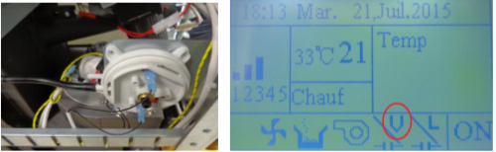

Fault finding in the following order:
- Control # 1 - Firstly it is essential to start by cleaning the internal circuit of the soot/ ash if this was not done. Please note that cleaning does not consist of a simple vacuuming in the home and the burning crucible. A built up of soot/ ash can cause a default setting of the switch but also an imperfect combustion and a danger to users and home.
- Control # 2 - you must ensure that the extraction smoke engine works well, it means that it absorbs well the combustion air behind the stove by the pipe with diameter 45mm, the air goes well through the internal circuit to get out of your discharge pipe.
- Control 3 - The small black or white hose extending from the switch to go to the back of the fireplace can be clogged with ash, it can also be cut, porous or simply disconnected. In some cases, the nut holding the metallic pipe at the intake of the fireplace is simply released and causes an air intake. The location and installation may be different due to the stoves models, please just follow the flexible pipes.
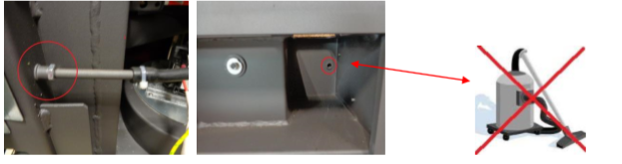
Photo 1 (above left): nut holding the metal pipe must be controlled and tighten if necessary.
Photo 2 (above right): the switch measures the draw by the little hole which is located inside the stove range, behind or above the ashtray depending on the models Strauss Schenger or stoves. It can be blocked but before vacuuming it is imperative to disconnect the black pipe that enters to the switch. Otherwise you risk destroying the switch. Locate the tip on which it was connected prior to the return to the right place.
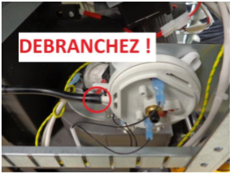 (DISCONNECT)
- Control 4 - the pressure switch can be DEFECTIVE or the electrical connections are bad. This test should be performed at last and only after strictly following the above instructions.

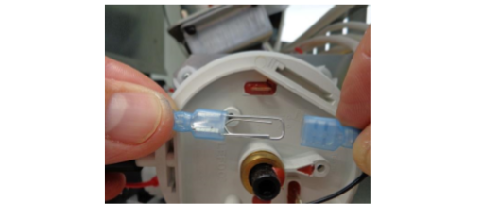
- Disconnect the two blue terminals and connect them together with a paper clip if you do not have electric wire. Make a good connection so that there are no false contacts. The "V" will then appear permanently in the display, no matter the stove is on or off.
- If the "V" still does not appear, there is a problem of connection, badly crimped lugs, black wire cut off, or disconnected from the power box *
- If the unit runs properly while the two blue ports are connected while by-passing the pressure switch then this will be the issue.
- You can re-set the pressure switch by unscrewing the dial and screwing back in until it ‘clicks’
- If this still does not work once the blue ports are re-connected then the pressure switch will need to be replaced.

